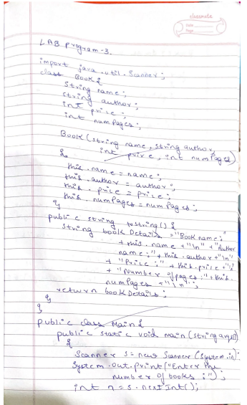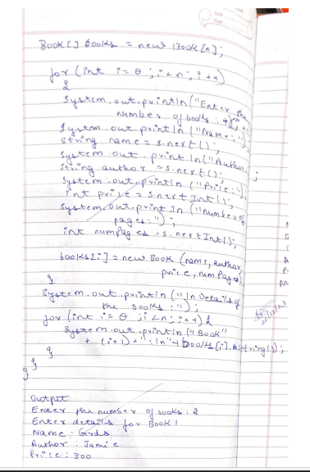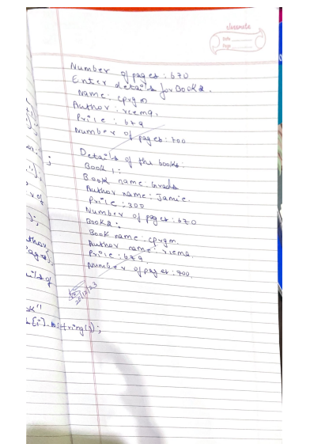

Code:-

import java.util.Scanner;  
  
class Book {  
    String name;  
    String author;  
    int price;  
    int numPages;  
  
     
    Book(String name, String author, int price, int numPages) {  
        [this.name](http://this.name/) = name;  
        this.author = author;  
        this.price = price;  
        this.numPages = numPages;  
    }  
  
     
    public String toString() {  
        String bookDetails = "Book name: " + [this.name](http://this.name/) + "\n"  
                + "Author name: " + this.author + "\n"  
                + "Price: " + this.price + "\n"  
                + "Number of pages: " + this.numPages + "\n";  
        return bookDetails;  
    }  
}  
  
public class Main {  
    public static void main(String args[]) {  
        Scanner s = new Scanner(System.in);  
        System.out.print("Enter the number of books: ");  
        int n = s.nextInt();  
  
         
        Book[] books = new Book[n];  
  
         
        for (int i = 0; i < n; i++) {  
            System.out.println("Enter details for Book " + (i + 1));  
            System.out.println("Name: ");  
            String name = s.next();  
            System.out.println("Author: ");  
            String author = s.next();  
            System.out.println("Price: ");  
            int price = s.nextInt();  
            System.out.println("Number of pages: ");  
            int numPages = s.nextInt();  
   
            // Create a new Book object with the entered details  
            books[i] = new Book(name, author, price, numPages);  
        }  
  
  
        System.out.println("\nDetails of the books:");  
        for (int i = 0; i < n; i++) {  
            System.out.println("Book " + (i + 1) + ":\n" + books[i].toString());  
        }  
    }  
}

Output:-

